#1. Maker (a person who is passionate to explore materials and what they can do.)

# The Simple Tree

If you nave NOT read the Book “The Giving Tree” by Shel Silverstein. It is a must to understand passion. Here’s picture of the cover:

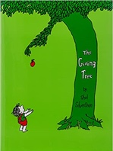 Please read and share.

We will begin our discovery with the simple shape of the tree. Just about everybody

can draw a tree. From very young you probably drew a tree like this:

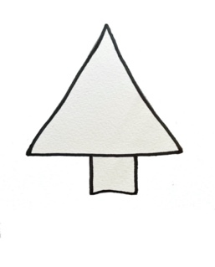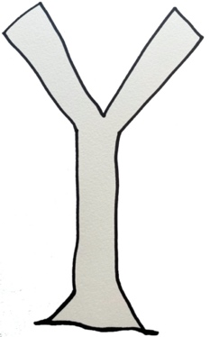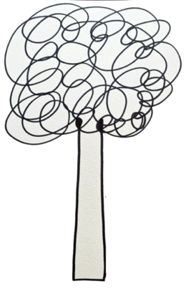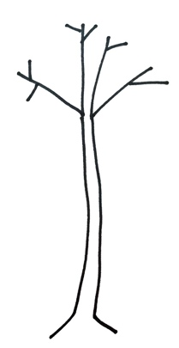

Pine Tree “Y” Tree Bad Hair Day the Dead Tree

… and these are okay. If you are 6 or 7 years old.

BUT – (Don’t grow up!) on a single piece of paper draw the “Y” Tree above. Now let’s explore by coloring, using colored paper, markers, using fancy papers and even tearing paper! Your drawing doesn’t have to be perfect. Remember we are exploring materials.

After you have used crayons and markers – let’s try fancy papers. They are all available at the craft store or order on line. Of course (!) yours **DO NOT have to be the same** as ours. You might like to begin with a green and brown tree! Or Purple and Orange…

**The Orange and Black Tree** (using three different papers)

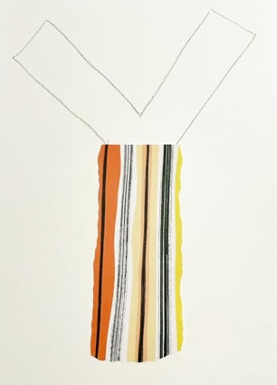 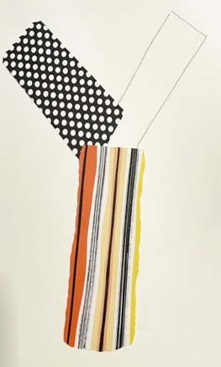 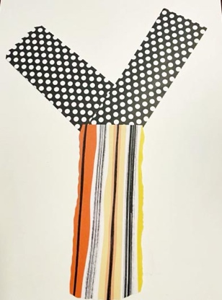 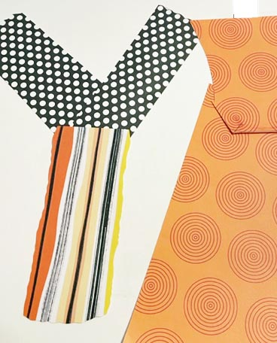

cut and glue these pieces above in place on your paper.

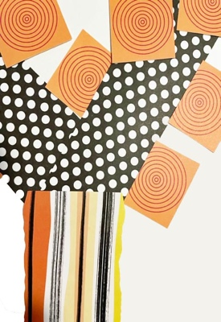 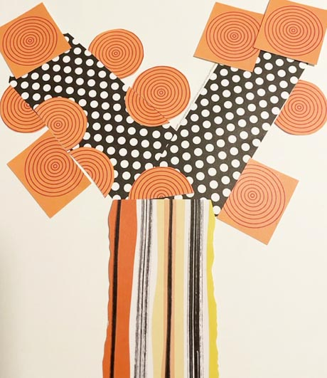

At this point we didn’t like the squares for the leaves. So we cut the circles in half.

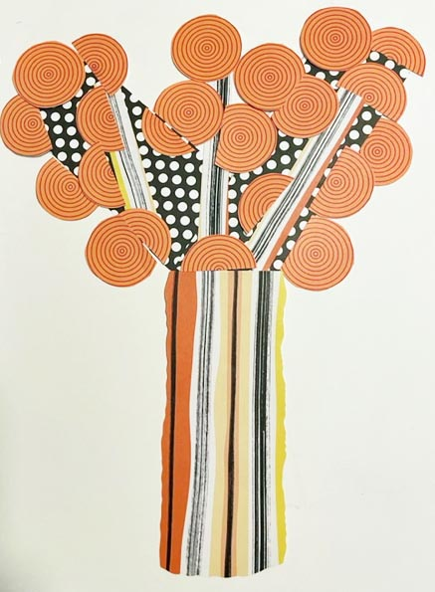

We added additional branches from the trunk paper

before gluing. This looks better we think…

Is there something else we could add to give more dimension? Hmmm. Let’s explore some options then you can choose what you like.

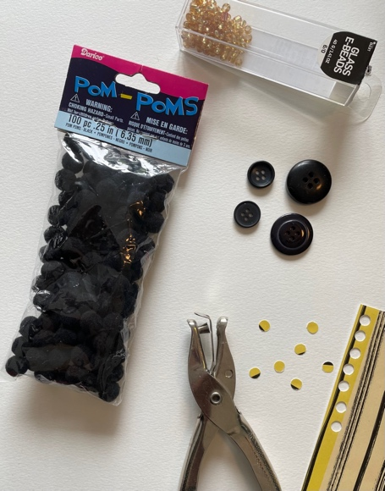 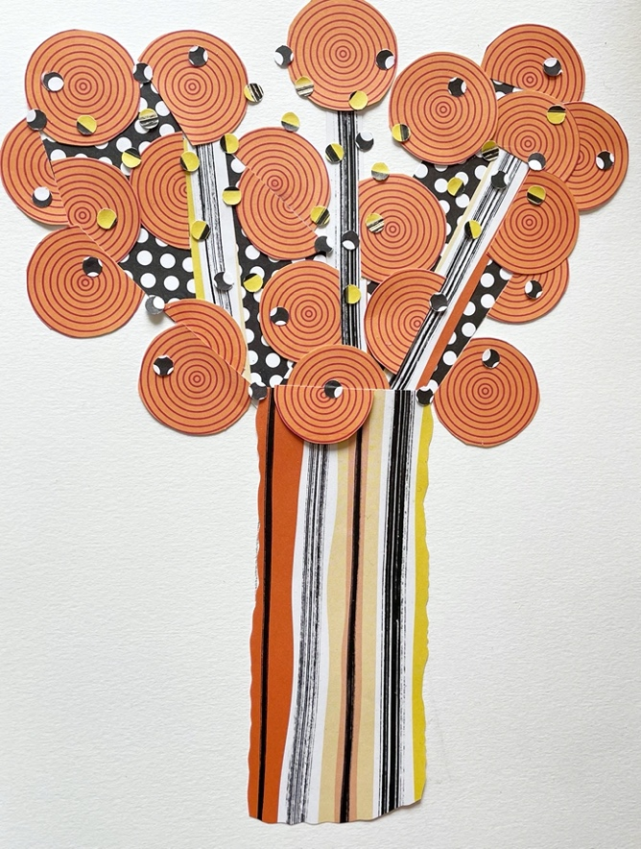

Pompoms, beads, buttons, small hole punches… we chose the small hole punches.

Don’t forget to photo all your work so you can share.

other ideas to spark your creativity:

The Pine Tree (lol)

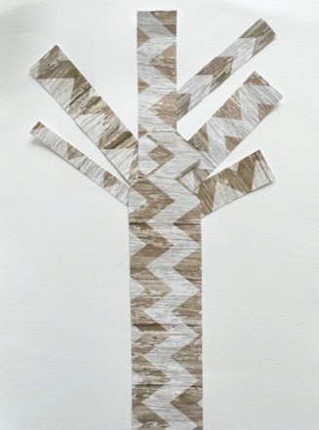 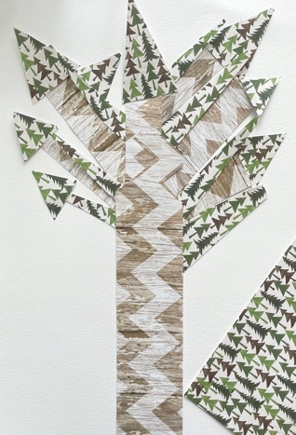 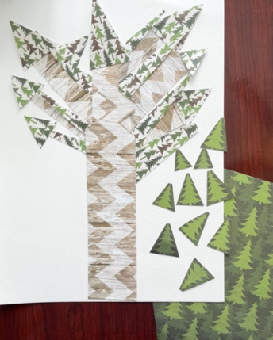 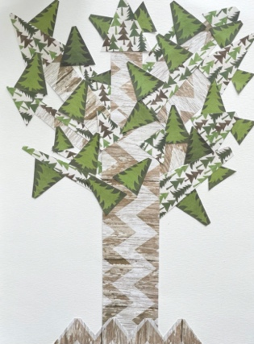

The Tree House

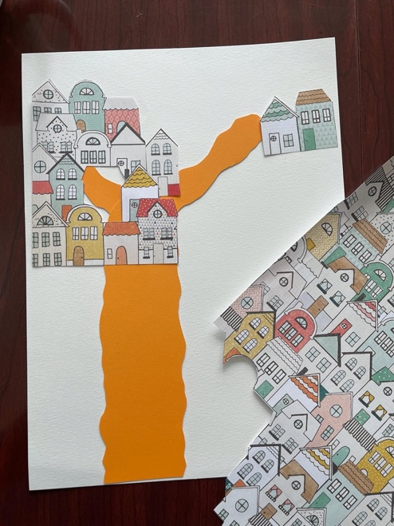 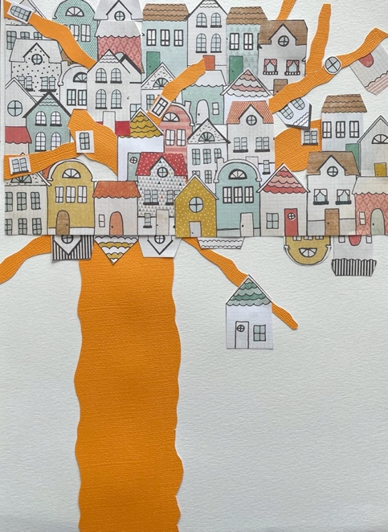

**The Pink and Turquoise Tree** (Using only two papers-plus pink pearls)

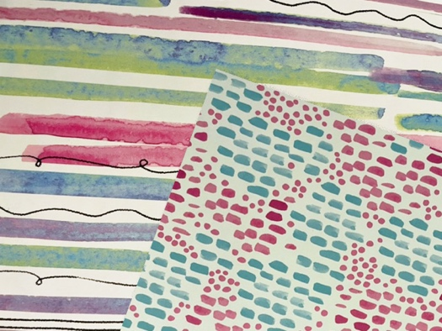 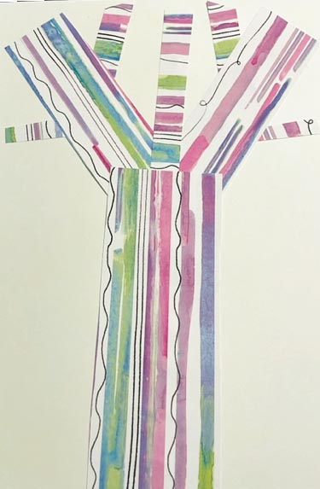

Your paper choice needs to have similar colors. Cut and glue trunk and branches

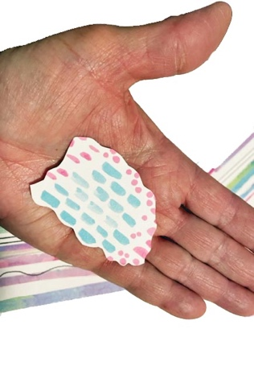 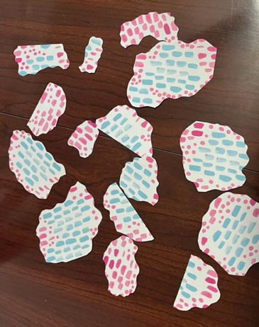

cut shapes with scalloped edges. You will need about 15 or so.

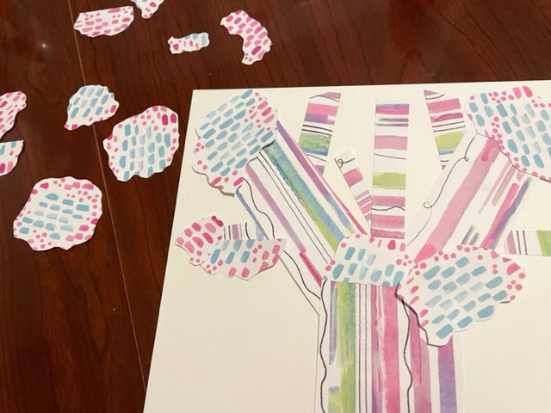 Place your shapes before gluing.

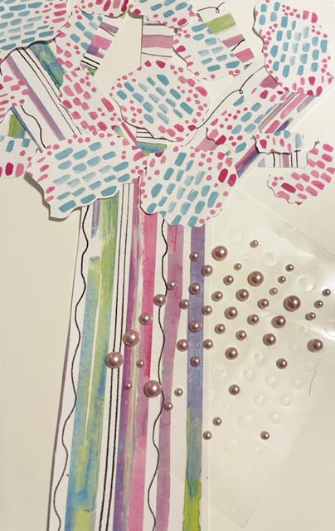 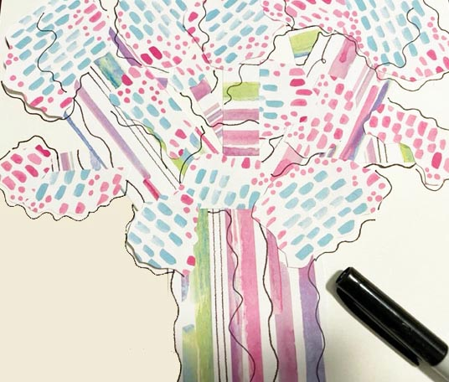

…possible pearls to stick on. This is a vital step with this tree. Use

a fine line marker to draw lines all around,

similar to the paper, to **unify** the image.

add your press on pearls if you choose to

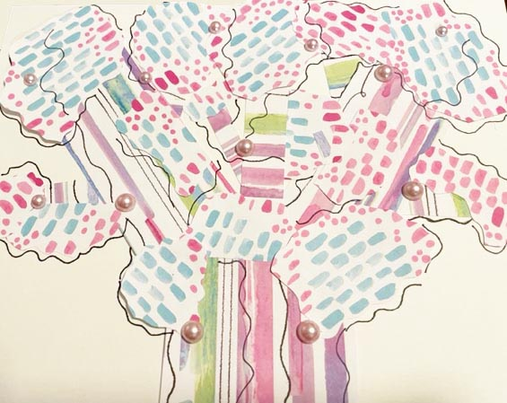 final image… 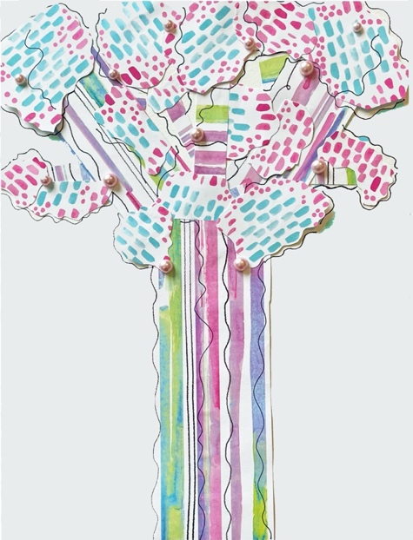

Extras: If you have Photoshop or similar software on your computer… try these next!

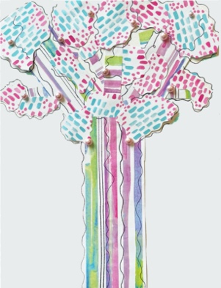  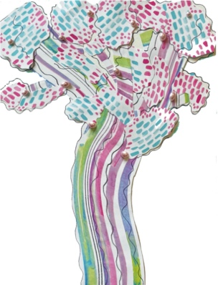 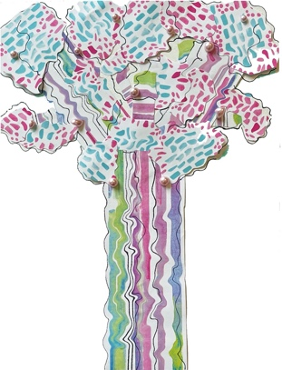

Original Crystallize tool Twirl tool Liquify tool

and finally --- Enhance the colors, duplicate the layers and create 6 different trees.

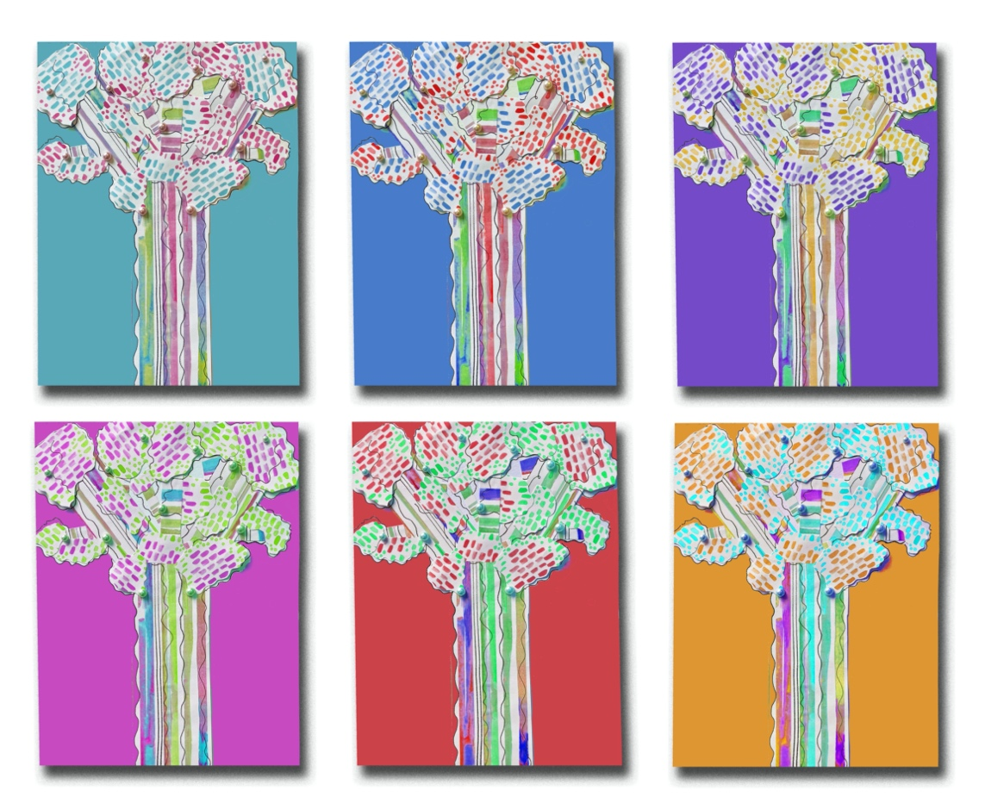

Place in a frame like a professional!